Republic of Korea: Recent Economic Developments and Outlook

# GDP growth in 2019 contracted

GDP growth contracted from 2.7% in 2018 to 2.0% in 2019. On the demand side, government expenditure, accounting for 17.3% of GDP, contributed the most with 1.1 percentage points (pp). Private consumption added 0.9pp. Net exports shared 0.9pp. On the other hand, gross capital formation shaved 0.8pp from growth. On the supply side, services, accounting for 56.8% of GDP, contributed the most with 1.5pp. Industry (including construction) gave 0.3pp. Meanwhile, agriculture had trivial contribution to growth this period.

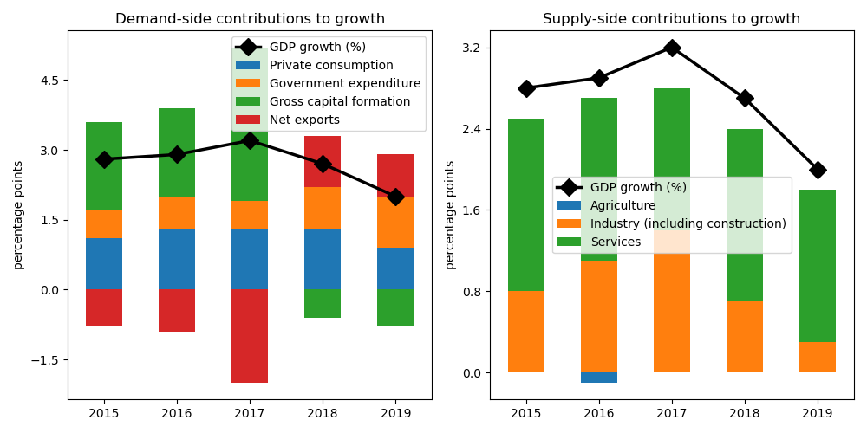

## Government expenditure achieved largest gain on the demand side

Government expenditure jumped by the biggest margin at 6.5% annual growth. Private consumption increased by 1.9%. On the other hand, gross capital formation shrank by 2.5%. On the other hand, net exports plunged by 39.0%.

## On the supply side, growth in services accelerated the fastest

Services expanded by the largest edge at 2.7% annual growth. Agriculture increased by 2.4%. Industry (including construction) expanded by 1.0%.

## Unemployment declined; inflation improved

Unemployment rate declined from 3.8% in 2018 to 3.7% in 2019. Consequently, inflation improved from 1.5% to 0.4%. At the end of the year, the central bank set the policy rate at 3.0%.

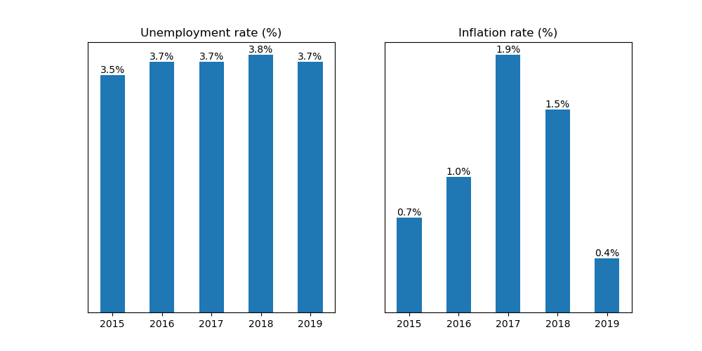

## Current account balance posted a surplus

Current account balance (CAB) recorded a surplus at 3.7% of GDP in 2019. Net trade in goods and services reached USD 53.8 billion. In 2018, CAB posted a surplus at 4.5% of GDP.

China is the country's top export destination accounting for 25.1% of total exports in 2019. Other major exports partners include USA (13.6%), Viet Nam (8.9%), China, Hong Kong SAR (5.9%), and Japan (5.2%). Top export commodities are electrical machinery and equipment and parts thereof; sound recorders and reproducers; television image and sound recorders and reproducers, parts and accessories of such articles, accounting for 28.3% of total exports.

For imports, top imports origin in 2019 is China (21.3% of total imports), followed by USA (12.3%), Japan (9.5%), Saudi Arabia (4.3%), and Viet Nam (4.2%). Major import commodities are mineral fuels, mineral oils and products of their distillation; bituminous substances; mineral waxes, accounting for 25.3% of total imports.

# Output contracted in Q3 2020

Output plunged by 1.2% year-on-year in Q3 of 2020. Growth in overall economic activity improved from a contraction of 2.7% in the previous quarter. Government expenditure picked up by the biggest margin at 4.8% annual growth. On the other hand, private consumption contracted by 4.2%. Meanwhile, gross capital formation was flat over the same period.

## Retail sales picked up

Retail sales picked up by 2.3% year-on-year in October of 2020. Growth in the retail sector worsened from an expansion of 4.1 in September, reflecting muted trade activity.

## Industrial output expanded

Industrial production expanded by 2.1% year-on-year in October, adecrease from 2.2% growth in the previous month. Growth in manufacturing worsened to 2.1% from 2.5%.

## Inflation slowed down

Overall inflation slowed down to -1.6% year-on-year in October from -1.4% in the previous month.

Republic of Korea's central bank held unchanged the official policy rate to 1.75% in November from the same in October.

# Outlook tilted downwards this year

On November 2020, Consensus Economics panelists project Republic of Korea's economic growth ending in 2020 at -1.2%. In 2021, the panelists foresee growth at 3.3%. Over the same period, consumption is expected to grow by -4.1% and 3.3%, while investment is projected to grow by 2.0% and 2.4%. Industrial production is seen to grow by -0.5% and 3.7%.

Meanwhile, Consensus Economics panelists foresee inflation averaging in 2020 at 0.5%. In 2021, the panelists project inflation at 1.1%.